Neural Networks
Activation function - A function that enables neural networks to learn nonlinear (complex) relationships between features and the label.
Hidden layer - A layer in a neural network between the input layer (the features) and the output layer (the prediction). Each hidden layer consists of one or more neurons.
Linear model - A model that assigns one weight per feature to make predictions. (Linear models also incorporate a bias.)
Model - In general, any mathematical construct that processes input data and returns output. Phrased differently, a model is the set of parameters and structure needed for a system to make predictions.
Neural network - A model containing at least one hidden layer. A deep neural network is a type of neural network containing more than one hidden layer.
Node (neural network) - A neuron in a hidden layer.
Nonlinear - A relationship between two or more variables that can't be represented solely through addition and multiplication. A linear relationship can be represented as a line; a nonlinear relationship can't be represented as a line.
Nodes and Hidden Layers
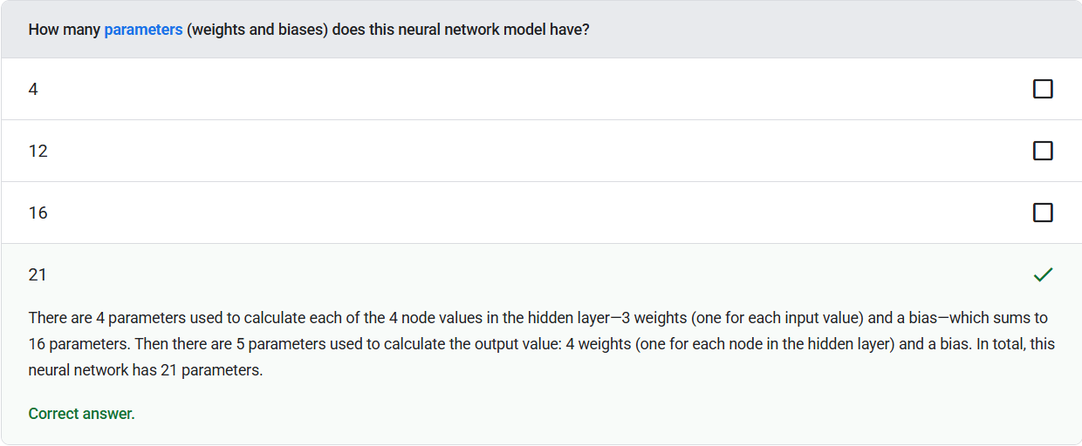
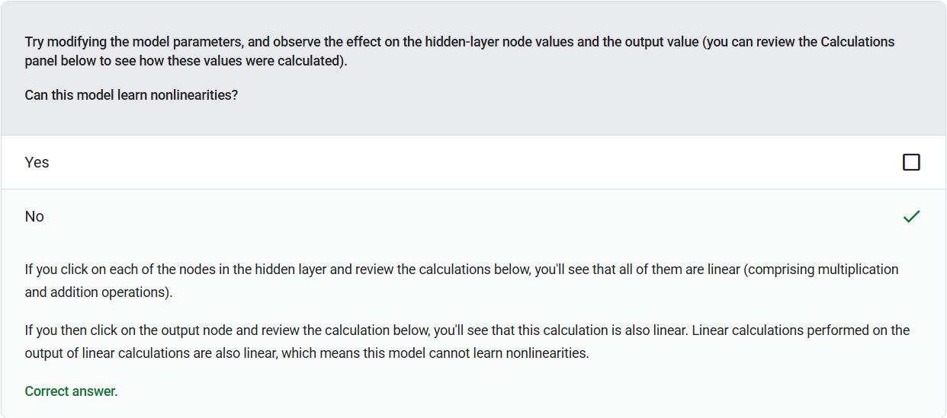

Bias (math) or bias term - An intercept or offset from an origin. Bias is a parameter in machine learning models, which is symbolized by either of the following:
• b
• w0
Hidden layer - A layer in a neural network between the input layer (the features) and the output layer (the prediction). Each hidden layer consists of one or more neurons.
Input layer - The layer of a neural network that holds the feature vector. That is, the input layer provides examples for training or inference.
Linear model - A model that assigns one weight per feature to make predictions. (Linear models also incorporate a bias.)
Model - In general, any mathematical construct that processes input data and returns output. Phrased differently, a model is the set of parameters and structure needed for a system to make predictions.
Neural network - A model containing at least one hidden layer. A deep neural network is a type of neural network containing more than one hidden layer.
Neuron - In machine learning, a distinct unit within a hidden layer of a neural network. Each neuron performs the following two-step action:
• Calculates the weighted sum of input values multiplied by their corresponding weights.
• Passes the weighted sum as input to an activation function.
Nonlinear - A relationship between two or more variables that can't be represented solely through addition and multiplication. A linear relationship can be represented as a line; a nonlinear relationship can't be represented as a line.
Parameter - The weights and biases that a model learns during training.
Activation Functions
Watched Video

Activation function - A function that enables neural networks to learn nonlinear (complex) relationships between features and the label.
Sigmoid function - A mathematical function that "squishes" an input value into a constrained range, typically 0 to 1 or -1 to +1.
Vanishing gradient problem - The tendency for the gradients of early hidden layers of some deep neural networks to become surprisingly flat (low). Increasingly lower gradients result in increasingly smaller changes to the weights on nodes in a deep neural network, leading to little or no learning.
Training Using Backpropagation
Watched Video

Backpropagation - The algorithm that implements gradient descent in neural networks.
Dropout regularization - A form of regularization useful in training neural networks. Dropout regularization removes a random selection of a fixed number of the units in a network layer for a single gradient step.
Exploding gradient problem - The tendency for gradients in deep neural networks (especially recurrent neural networks) to become surprisingly steep (high). Steep gradients often cause very large updates to the weights of each node in a deep neural network.
Vanishing gradient problem - The tendency for the gradients of early hidden layers of some deep neural networks to become surprisingly flat (low). Increasingly lower gradients result in increasingly smaller changes to the weights on nodes in a deep neural network, leading to little or no learning.
Coding Exercise
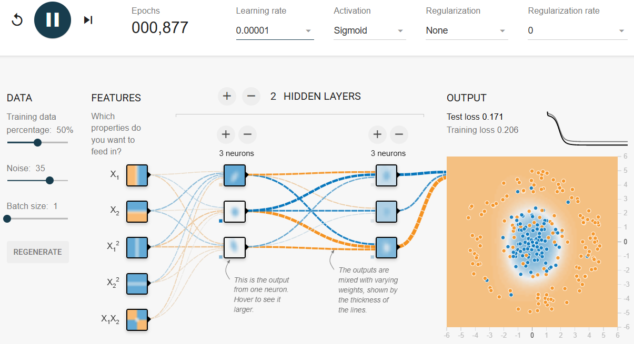

Test loss - A metric representing a model's loss against the test set. When building a model, you typically try to minimize test loss.
Training loss - A metric representing a model's loss during a particular training iteration.
Multi-Class Classification

Binary classification - A type of classification task that predicts one of two mutually exclusive classes:
• the positive class
• the negative class
Multi-class classification - In supervised learning, a classification problem in which the dataset contains more than two classes of labels.
One-vs.-all - Given a classification problem with N classes, a solution consisting of N separate binary classification model—one binary classification model for each possible outcome.
Softmax - A function that determines probabilities for each possible class in a multi-class classification model. The probabilities add up to exactly 1.0.

Test


